
Mount Lourdes Grammar School
Fire Safety Policy

Zones
In the event of the fire alarm being raised, the school should be evacuated in a phased manner. To enable this to be done the school has been divided into zones. Two of the zones are detached buildings (Technology Building and St. Fanchea’s).
The main school building has been designed and built in one zones. This has been designed to contain fire and smoke for a minimum of two hours.

The zones are as follows:
Zone 1 – Entire Main Building
- St Catherine’s including the canteen
- St Anne’s
- St Paul’s
- Sacred Heart House
- Sports Hall / Main Assembly Hall block
Zone 2 – Technology Suite
Zone 3 – St Fanchea’s Building

Figure 1 illustrates the zones:

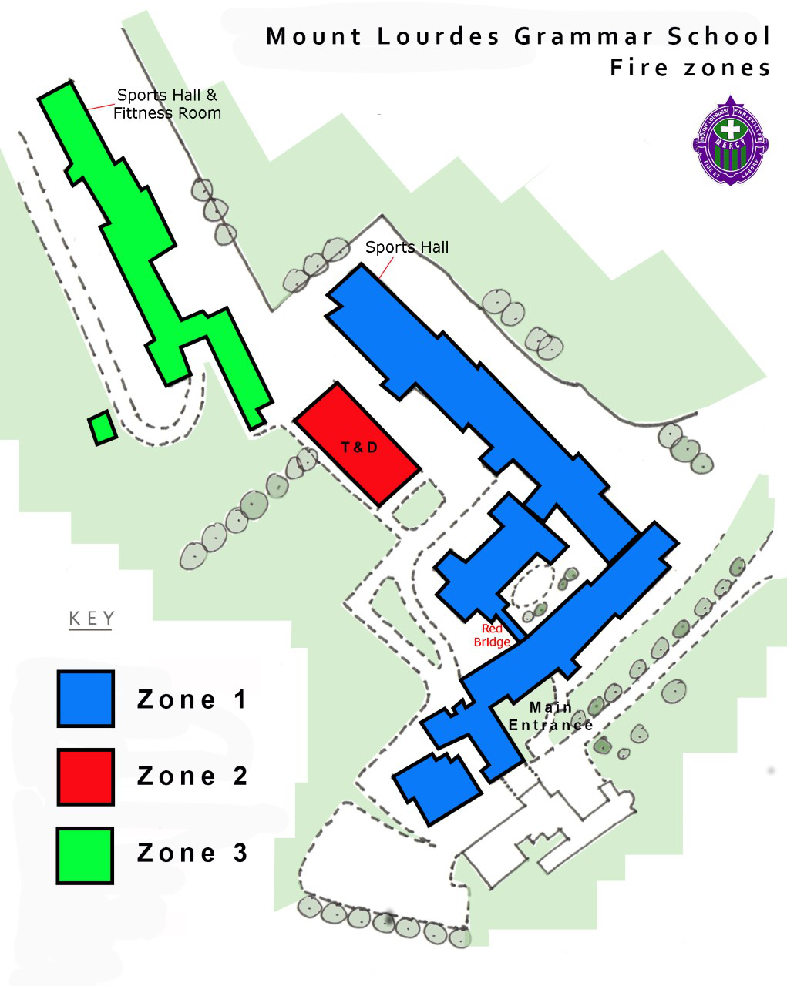Figure 1
Emergency Procedures
In the event of suspecting or detecting any fire the following procedures should be followed:

Raise the Alarm
  - Break the glass at one of the alarm / call points
  - Inform the main office (ext. 100)

During school hours it is the responsibility of the office staff to call the fire services. This will only be done once the existence of a fire has been verified by a member of staff.
The office staff will notify the fire services of which school entrance to take i.e. Belmore Street or Mill Street.

During school hours a member of the support staff (Mr Kevin McManus – Mill Street Entrance and M/s Marita Cosgrove – Belmore Street Entrance) will meet the fire services at the appropriate entrance gate and provide directions as to where in the building the fire is located. Mr Joe Gunn (Fire Warden / Technology and Design Technician) will respond to the alarm by identifying the location of the fire from the fire control panel. The deputy Fire Warden is Mr Kevin McManus. Mr Gerard Quinn (Senior Teacher) will be contacted by the main office to unlock barrier between school buildings to allow emergency vehicle access. (In the event that Mr Kevin McManus is acting as Fire Warden, Mr Gerard Quinn will unlock barrier and proceed to meet fire services at Mill Street Entrance)

The Principal will determine the need, if any, for the complete evacuation of the school. In her absence, her nominated deputy will undertake this role (Vice Principal, Mr Jim Devine or in his absence, a member of the Senior Leadership Team). This decision should be made within 30 minutes of the alarm being activated.

If a fire is detected outside school hours the alarm monitoring company will contact the fire services.

The Alarms
The fire alarm in the school has two sounds:
- a continuous tone
- a one second pulsed tone

In the case of the pulsed alarm sounding:
- Remain in the room until further notice
- Be prepared for possible evacuation
- If you need to evacuate the alarm will change to a continuous tone
- In this case leave the building by the nearest exit and assemble on the Tennis Courts
- Follow the evacuation procedures outlined below (as for continuous alarm)

In the case of the continuous alarm sounding:
- Close all windows in your room
- Evacuate your room, leave the building by the nearest exit and assemble on the Tennis Courts
- Pupils leave all bags in the room
- Any machines / appliances/ processes / power supplies that need to be stopped or isolated should be
- Ensure that all doors are closed
- Each teacher will ensure that all pupils in his/her care at the time of the alarm proceed to the assigned assembly point. S/he must remain with the pupils until further instructions are received
- The study hall supervisor will take responsibility for students in the Study Hall
- Mrs Rita Doran/Mrs Dee Kerr will take responsibility for students in Sick Bay
- Staff on Common Room Floor will assist with evacuation of pupils from the Study Hall and the Common Room. (currently Mr Jim Devine, Mrs Carmel McCarron, Mrs Dee Kerr* if in reprographics)
- The Head of Department / Support Staff Line Manager should act as a Fire Marshall in their respective area if evacuated
- Mr Paul Eccles will assist with the evacuation of pupils from Room 60
- In the event of a whole school evacuation, Mrs Michelle Judge (Senior Teacher) will act as a Marshall outside the main staffroom and ensure that students move in a swift manner to their evacuation point.
- On route to the evacuation point Mrs Jane McGeoghan (Senior Teacher) will check that the Tennis Pavilion is unoccupied.
- If students are missing, staff should inform the Principal or Vice Principal or member of the Senior Leadership Team
- No one may re-enter the school building until authorised to do so by the Principal or her deputy.
- Lifts should not be used.

Break, Lunch Time and Change of Class
Should an alarm sound (pulsed or continuous) during either break or lunchtime (both junior and senior lunches) the following procedure should be carried out:
- Evacuate the entire school and assemble on the Tennis Courts
- Pupils line up beside their form class designated area
- Form teachers go to their form class and ensure all students are present
- Teachers who were on rota for morning registration must go to that form group and ensure that all students are accounted for
- If students are missing, teachers must inform the Principal or Vice Principal
- No one may re-enter the school building until authorised to do so by the Principal or her deputy.

Entrance to the Tennis Courts
Top Tennis Court: Years 8,9,10 & 11. Approach the courts by the path and use the gate directly below the tennis pavilion regardless of the type of evacuation.

Lower Tennis Court: Years 12, 13 & 14. Approach the courts using the steps and use the appropriate gate regardless of the type of evacuation.

Students evacuating the St Fanchea’s building should proceed to the designated Tennis Court by the most direct route i.e. using the bottom path.

Pupil Roll Call:
- Heads of Year / Form Teacher will record the name, time of departure and time of return of each student who has permission to leave the school during the day. In the case of a whole school evacuation they will bring this list to the assembly point if possible and safe to do so
- These lists will be used in conjunction with the form teachers’ absentee report to determine if there are still students present within the school
- If students are unaccounted for the emergency services will be informed upon arrival.

Staff Roll Call
- A list of staff absentees and staff who have left the school premises will be maintained in the main office
- This book/record will be brought to the Tennis Courts by a member of the administration staff in the event of a whole or partial evacuation
- Katherine Colton, Administrator, will take responsibility for taking the roll call of all support staff
- The Principal or her deputy will take responsibility for taking the roll call of teaching staff
- If staff are unaccounted for the emergency services will be informed upon arrival.

Evacuation after 3.30pm
After school hours it is the responsibility of the office staff to call the fire services. This will only be done once the existence of a fire has been verified by a member of staff. The office staff will notify the fire services of which school entrance to take i.e. Belmore Street or Mill Street.

- If the alarm rings (pulsed or continuous) after 3.30pm all staff and students should assemble in the car park opposite the staffroom
- Members of staff taking after school activities will ensure that all students in his/her care at the time of the alarm proceed to the assembly point. He/she will remain with the students until further instructions are received
- Katherine Colton, Administrator will ensure that all support staff are accounted for
- The Principal, member of the Senior Leadership Team or other member of staff who is in the building at the time of the alarm will ensure that students and staff are accounted for, in so far as it is possible
- No one may re-enter the school building until authorised to do so by the Administrator, member of staff, Principal or her deputy
- If staff/students are unaccounted for the emergency services will be informed upon arrival.

Disabled Staff and Students
Under the Disability Act 2010, disabled staff, disabled students and their Classroom Assistants, will be issued with a Personal Emergency Evacuation Plan (PEEP). Individualised plans will be drawn up in consultation with the student, her Classroom Assistant and the Learning Support Co-ordinator. This process will be overseen by and training provided by Mr Jim Devine, Vice Principal. The PEEP will identify the Call Point if necessary. The Secretary in the Main Office will check the Disabled Call Point.

Evacuation of Examination Halls during External Examinations
In the case of the pulsed alarm sounding
- Remain in the examination hall until further notice
- Continue the examination but be prepared for a possible evacuation
- If you need to evacuate the alarm will change to a continuous tone
- In this case leave the examination hall by the nearest exit and assemble on the Tennis Courts
- Follow the evacuation procedures outlined below (as for continuous alarm)

In the case of the continuous alarm sounding:
- Evacuate the examination hall, leave the building by the nearest exit and assemble on the Tennis Courts
- Examinees leave all examination material in the examination hall
- Invigilators will ensure that all examinees proceed to the assigned assembly point. They must remain with the examinees until further instructions are received
- Examinees should be instructed not to communicate with each other
- No one may re-enter the school building until authorised to do so by the Principal or her deputy.
- Examinees will be escorted back to the examination hall by the invigilators when authorised to do so
- The Examination Board will be contacted as soon as possible to alert them of the disruption to the examinations and to receive further guidance

Fire Notices
Each room in the school will display a Fire and Evacuation Procedures Notice. This will be posted in a clear and prominent position and should not be obstructed. It is the responsibility of teachers using that room to notify the Principal or Vice Principal should such a notice not be present or is damaged.

Fire Alarm Checks
The fire alarm will be checked weekly by Mr. Joe Gunn, Fire Warden, to ensure its proper operation. Each week a different alarm point will be used. These checks will be logged and a record maintained in the Fire Safety Measures Log Book which is held in the Fire Proof Cabinet in the Main Entrance Lobby.

Fire Drills
A fire drill will be carried out at least once each year and when possible once each term.

Fire Extinguishers
Fire extinguishers are located throughout the school in corridors as well as classrooms which are deemed to have an increased risk of fire. All fire extinguishers will be checked and maintained annually by an authorised and qualified third party. Administration of this annual check will be carried out by the Administrator, Mrs Katherine Colton. Mr Joe Gunn will conduct a termly check to ensure that all fire extinguishers are in their designated location.

Flammable Chemicals in the Science Department
A list of the chemicals held within the Science Department will be available at all times in the Main Office. Should a fire break out in the vicinity of the science rooms or an evacuation of the entire building takes place, the Emergency Services will be provided with a copy of this list.

Such chemicals are stored in specially designed and clearly labelled fire resistant cabinets in the storeroom off room 15 (Biology Laboratory) on the bottom corridor. Flammable chemicals are stored apart from oxidising chemicals to reduce the hazard should a fire break out.

The following lists are currently available in the Main Office:
- Inventory of chemicals awaiting disposal by a registered waste carrier (in store off the Greenhouse)
- Inventory of radioactive sources held in Physics Prep Room (Room 62/63)
- Inventory of Chemicals locked off Room 15.

Locations of Fire Alarm Control Panels
The control panels for the fire alarm are:
- At the main entrance of the school
- At the Assembly Hall entrance
- At the entrance to the Technology Suite
- At the main entrance to the St Fanchea’s building.

Post Incident Plan
In the event that the school building cannot be re-entered the following locations have been identified as locations for students to go to, if for example in the event of inclement weather.
- Holy Trinity Assembly Hall (Key Stage 3 students)
- St. Michael’s Community Centre (Key Stage 4 students)
- Enniskillen Scouts Centre (Post 16 students)
Students would exit the Tennis Court Evacuation point to go to these locations via the Gaelic Pitch and the Mill Street Entrance.

